The following method describes the method to find determinant of a matrix:

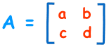

|A| = ad – bc

For a 3 x 3 matrix, the determinant is found as follows:

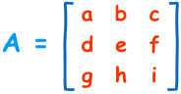

|A| = a(ei − fh) − b(di − fg) + c(dh − eg)

For 4 x 4 matrices and higher, the pattern is similar.

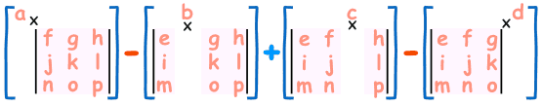

**Task 4.1**

Write a recursive function, find_determinant(mat) to find the determinant of an N x N matrix. Determine a suitable representation for a matrix. [8]

**Task 4.2**

Test your function using the matrix $\left[\begin{matrix}3 & 6 & 1 \\ 2 & 8 & 4 \\ 7 & 2 & 6\end{matrix}\right]$. Provide a screenshot of your output. [2]